**Assignment 3 Report**

MT17036

**Question 1**

**SiGMOID-NEURAL NETWORK**

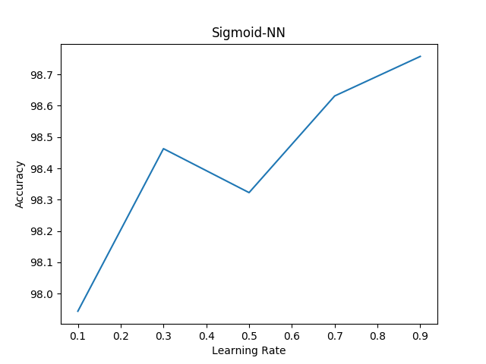

|  |  |
| --- | --- |
| Learning Rate | Accuracy |
| 0.1 | 97.94357102751263 |
| 0.3 | 98.46294216732173 |
| 0.5 | 98.32257158899495 |
| 0.7 | 98.63138686131386 |
| 0.9 | 98.75772038180799 |

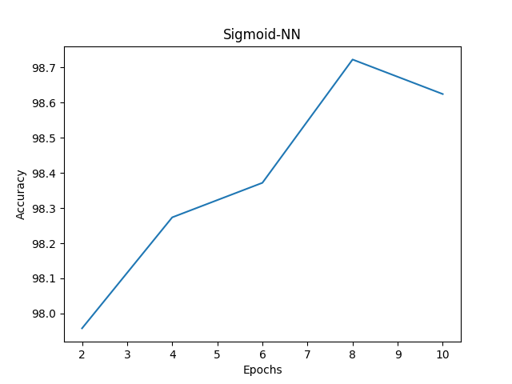

|  |  |
| --- | --- |
| Epochs | Accuracy |
| 2 | **97.9578947368421** |
| 4 | **98.27368421052631** |
| 6 | **98.37192982456142** |
| 8 | **98.72280701754387** |
| 10 | **98.62456140350878** |

**SIGMOID-SOFTMAX NEURAL NETWORK**

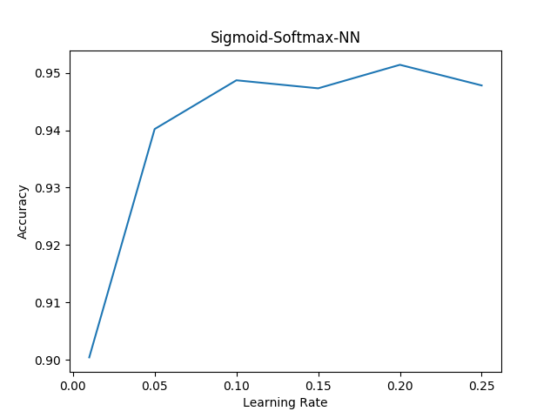

|  |  |
| --- | --- |
| Learning Rate | Accuracy |
| 0.01 | **90.04** |
| 0.05 | **94.02** |
| 0.10 | **94.87** |
| 0.15 | **94.73** |
| 0.20 | **95.14** |
| 0.25 | **94.78** |

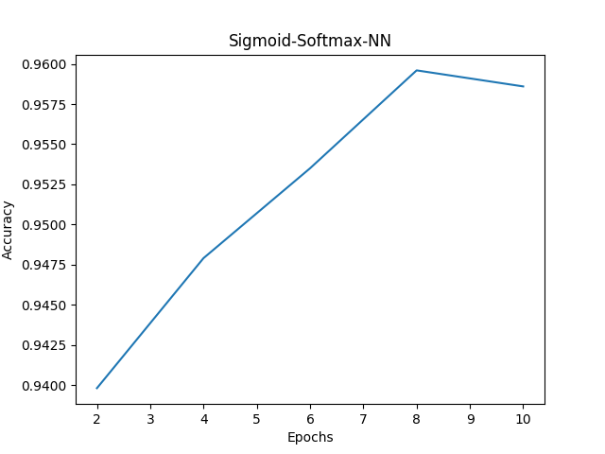

|  |  |
| --- | --- |
| Epochs | Accuracy |
| 2 | **93.98** |
| 4 | **94.79** |
| 6 | **95.35** |
| 8 | **95.96** |
| 10 | **95.86** |

**RELU-SOFTMAX NEURAL NETWORK**

SUBSET DATASET

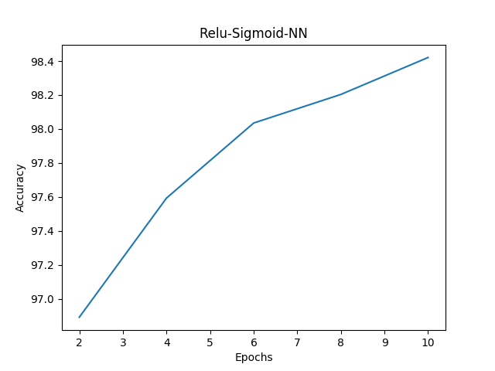

|  |  |
| --- | --- |
| Epochs | Accuracy |
| 2 | **96.89122807017544** |
| 4 | **97.59298245614035** |
| 6 | **98.03508771929825** |
| 8 | **98.20350877192983** |
| 10 | **98.42105263157896** |

FULL MNIST DATASET

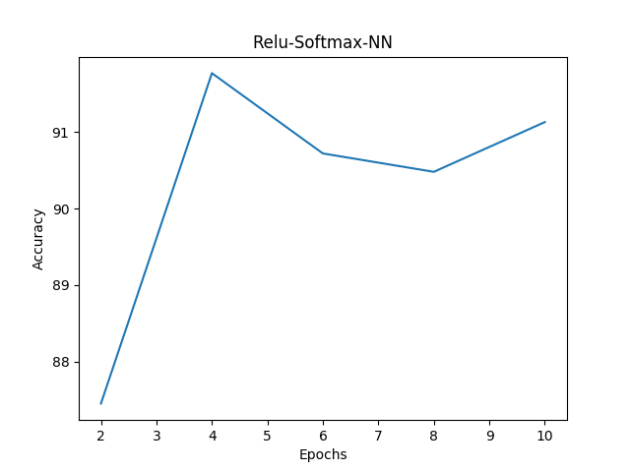

|  |  |
| --- | --- |
| Epochs | Accuracy |
| 2 | **87.45** |
| 4 | **91.77** |
| 6 | **90.72** |
| 8 | **90.48** |
| 10 | **91.13** |

**Question 2**

SIGMOID-SOFTMAX NEURAL NETWORK (DATASET SUBSET)

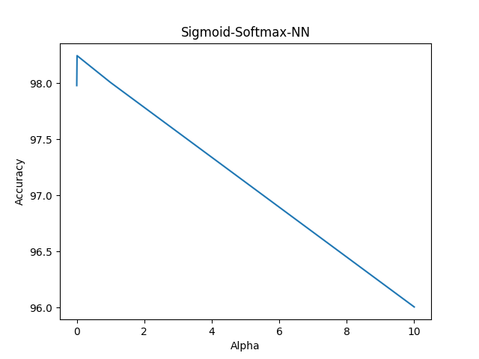

|  |  |
| --- | --- |
| Alpha(L2) | Accuracy |
| 0.001 | **97.97894736842105** |
| 0.1 | **98.24561403508771** |
| 1 | **98.00701754385965** |
| 10 | **96.00701754385963** |

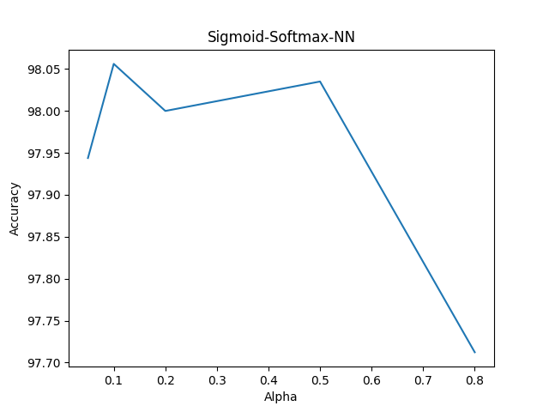

|  |  |
| --- | --- |
| Alpha | Accuracy |
| 0.05 | **97.9438596491228** |
| 0.1 | **98.0561403508772** |
| 0.2 | **98.0** |
| 0.5 | **98.03508771929825** |
| 0.8 | **97.7122807017544** |

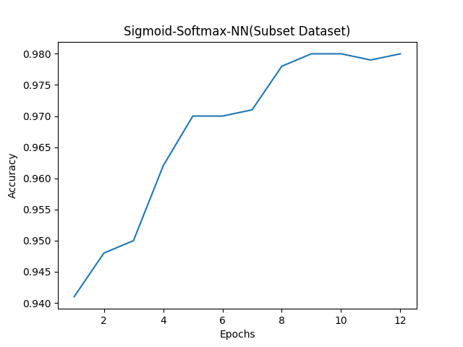

**SIGMOID-SOFTMAX NEURAL NETWORK (FULL DATASET)**

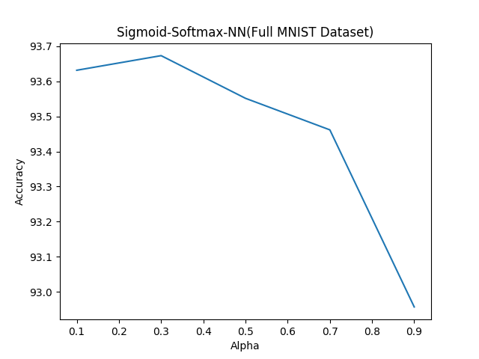

|  |  |
| --- | --- |
| Alpha | Accuracy |
| 0.1 | 93.63166666666667 |
| 0.3 | 93.67333333333333 |
| 0.5 | 93.55166666666666 |
| 0.7 | 93.46166666666667 |
| 0.9 | 92.95666666666666 |

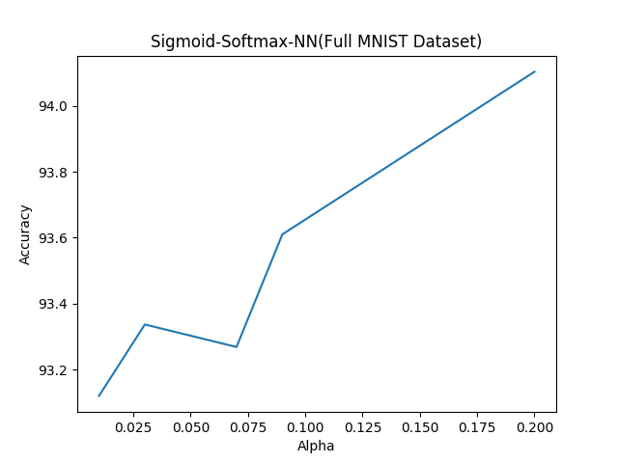

|  |  |
| --- | --- |
| Alpha | Accuracy |
| 0.01 | 93.11999999999999 |
| 0.03 | 93.33666666666666 |
| 0.07 | 93.26833333333335 |
| 0.09 | 93.61 |
| 0.20 | 94.10333333333334 |

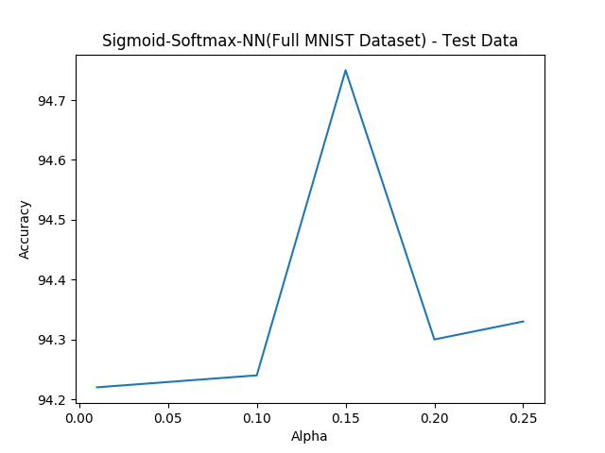

|  |  |
| --- | --- |
| Alpha | Accuracy |
| 0.01 | **94.22** |
| 0.1 | **94.24** |
| 0.15 | **94.75** |
| 0.2 | **94.3** |
| 0.25 | **94.33** |

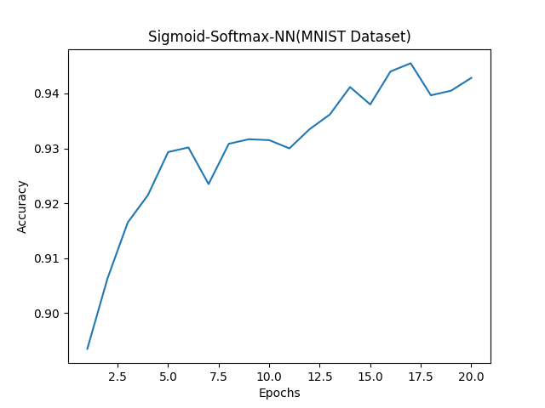

### **Question 3**

1. **Hidden Layers: 700,250,350,50**

**Alpha:0.75**

**Accuracy Achieved Against Test data: 97.35**

**2. Hidden Layers: 400,150,50**

**Alpha: 0.01**

**Accuracy Achieved Against Test data :97.33**

**3. Hidden Layers: 900**

**Alpha:0.1**

**Accuracy Achieved: 97.51**